Function and Procedure

Q.1. Given the relation

Instructor(id, name, dept_name, salary).

Write a function named salary-status that will take id as input parameter and return the salary status as follows:

If salary is less than 50000, the status will be ‘low income’

If salary is less than 80000 and greater than or equal to 50000, the status is ‘middle income’

Otherwise, the salary status is ‘high income’.

Write an SQL statement to find the id and salary status of all instructors.

Q2: Given the relation

student(id, name, dept_name, tot-credit).

Write a function named credit-status that will take id as input parameter and return the credit status as follows:

If total credit is less than 100, the status will be ‘Junior’

Otherwise, the status is ‘Senior’.

Write an SQL statement to find the id and credit status of all students.

Q. 3: Given the parents of students schema as follows:

Student_parents(F-NID, M-NID, S-id, F-name, M-name, street, city, annual-income)

Write a function named s-p-income-status that will take S-id type integer as input and return the status of the income as follows:

If annual-income is less than or equal to 2,50,000, the status is ‘Poor’. If annual-income is less than or equal to 30,00,000 and greater than 2,50,000, the status is ‘Middle Class’. Others are ‘Rich’.

Write SQL statement to find S-id, F-name and income status of all students of Dhaka city.

Procedure

Q4. Given the relation

Instructor(id, name, dept_name, salary).

Write a procedure named salary-update that will take two ids (i-id1 and i-id2) as input parameter and update the salaries as follows:

Consider i-id2 is always greater than i-id1.

For all instructors id less than or equal to i-id1, salary will be increased 20%.

For all instructors id less than or equal to i-id2 and greater than i-id1, salary will be increased 15%.

For all other instructors, salary will be increased 10%.

Call the procedure for updating salaries of instructors as above with i-di1 = 50 and i-id2 =80.

Q. 5: The courses taken by students have been given in the schema as follows:

Takes (id, course-id, semester, year, section-id, credit-hour, grade)

Write a procedure course-count-tot-credit that will have id (integer type) as input variable and two output variables t-course-count (integer type) and tot-credit (integer type). The total number of courses taken by the student id will be assigned to t-course-count and sum of the credit-hour of all courses taken by the student id will be assigned to tot-credit.

Call the procedure with id = 1001 and two variables t-count and t-ctrdit of integer type.

Index

|  |
| --- |
| Q. 1:  Give the following relation:  Person (NID, name, DOB, street, city)  Person relation is stored physically sorted order of NID. Answer the following questions.   1. Which type of indexing is created for DOB (primary/secondary)? 2. Which type of indexing is created for NID (primary/secondary)? 3. Why secondary index must be dense index? |

2: A table will be given. You will have to created dense index, sparse index, secondary index with bucket.

SQL will be given. You will have to explain how the SQL will be executed using the index.

3. Explain how the query SELECT * FROM instructor WHERE id = 83821 is executed using the given index as follows.

4. Explain how the query SELECT * FROM instructor WHERE salary < 70000 is executed.

**Instructor (id, name, dept_name, salary)**

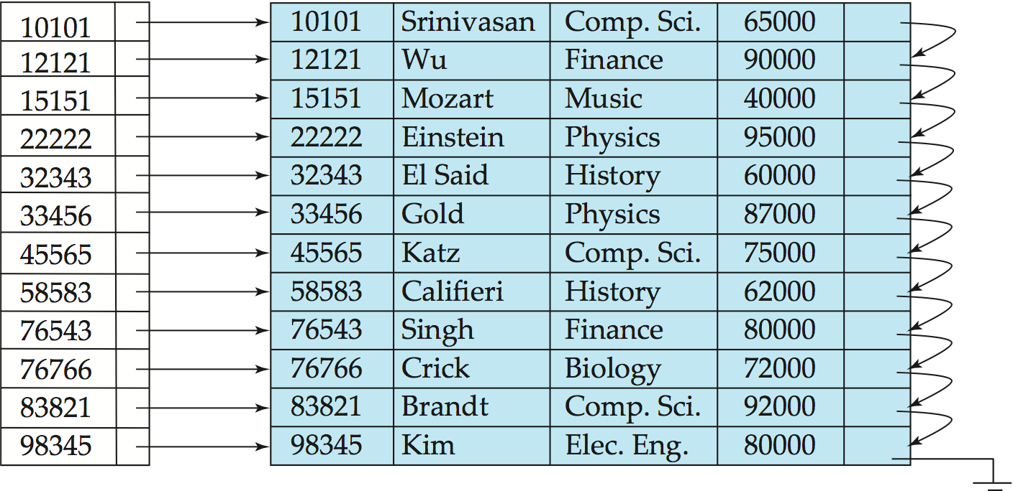

5. Construct a secondary index structure on dept_name of instructor relation as above.